Simultaneous Localization and Mapping (SLAM)
In August of 2006, I attended the SLAM Summer School (SSS06) at the University of Oxford. All presentations, related papers, and labs from SSS06 were distributed to participants in CD form. The contents of the CD were zipped up and can be downloaded by clicking the following link (note: file is password protected) --- sss06_cd.zip
Below was a series of lectures I created before attending the SLAM Summer Course. They cover the theory behind simultaneous localization and mapping (SLAM) as well as implementation in simulation (matlab) and experimentation (ER1 robot).
weg22@drexel.edu

Jump to a Lecture: 1 | 2 | 3 | 4 | 5

Lecture 1 - 07/14/06
Lesson Plan: Introduction to SLAM and Kalman Filter
Handouts, Slides and Homeworks
- Week-to-week schedule Schedule
- Intro to SLAM and Kalman Filter Lecture Notes
- Implementing a Kalman Filter Homework 1
- Measured voltage data for homework 1 data.m
- Read for next week An Introduction to the Kalman Filter

Lecture 2 - 07/21/06
Lesson Plan: Extended Kalman Filter
Handouts, Slides and Homeworks
- Extended Kalman Filter Lecture Notes
- Implementing an EKF Homework 2
- Robot position data for homework 2 dataEKF.m
- Good overview (has some errors) Simultaneous Localization and Mapping (SSS 2002)
- See here for more accurate derivations Autonomous Navigation and Map Building Using Laser Range Sensors in Outdoor Environments

Lecture 3 - 08/04/06
Lesson Plan: SLAM Implementation (Part I)
Handouts, Slides and Homeworks
- SLAM Implementation (Part I) Lecture Notes

Lecture 4 - 08/11/06
Lesson Plan: SLAM Implementation (Part II)
Handouts, Slides and Homeworks
- SLAM Implementation (Part II) Lecture Notes
- Implementing SLAM in simulation Homework 4
- Nebot Journal Paper download
- Matlab template for homework 4 download
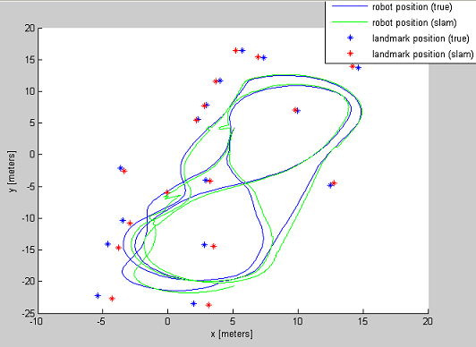

Lecture 5 - 08/17/06
Lesson Plan: Final Project
Handouts, Slides and Homeworks
- Final Project Handout
- VB code to collect encoder and laser data vbCode.zip
